Puppy and Natural Abilities Tests
Have you ever thought of trying a hunt test with your AWS but didn’t know if your dog has what it takes? Are you wondering if your puppy has natural hunting instinct?
Join us for the Puppy (less than 1 year of age) and Natural Abilities (one year plus) test. This will be a fun, pressure free chance to try something new with your AWS.
Goal: To give the handler an opportunity to see the dog’s natural hunting ability and encourage increased participation in hunting and hunting events.
The puppy or adult dog does not have to be steady at the line. The handler determines what object is used, could be bumper, bird or any toy. The dog should be willing to leave the line after the object is thrown. Ideally the dog will pick up the thrown object but it does not necessarily have to bring it right back to the handler. Judges just need to see the natural instinct to locate the object, pick it up and eventually retrieve it. The distance for the throw will be approx. 15 yards for puppies and 30 yards for adults.
This fun event will be held on Friday around lunchtime at the hunt test. We are asking that you pre-register so we make sure we have enough birds or bumpers ready to go.

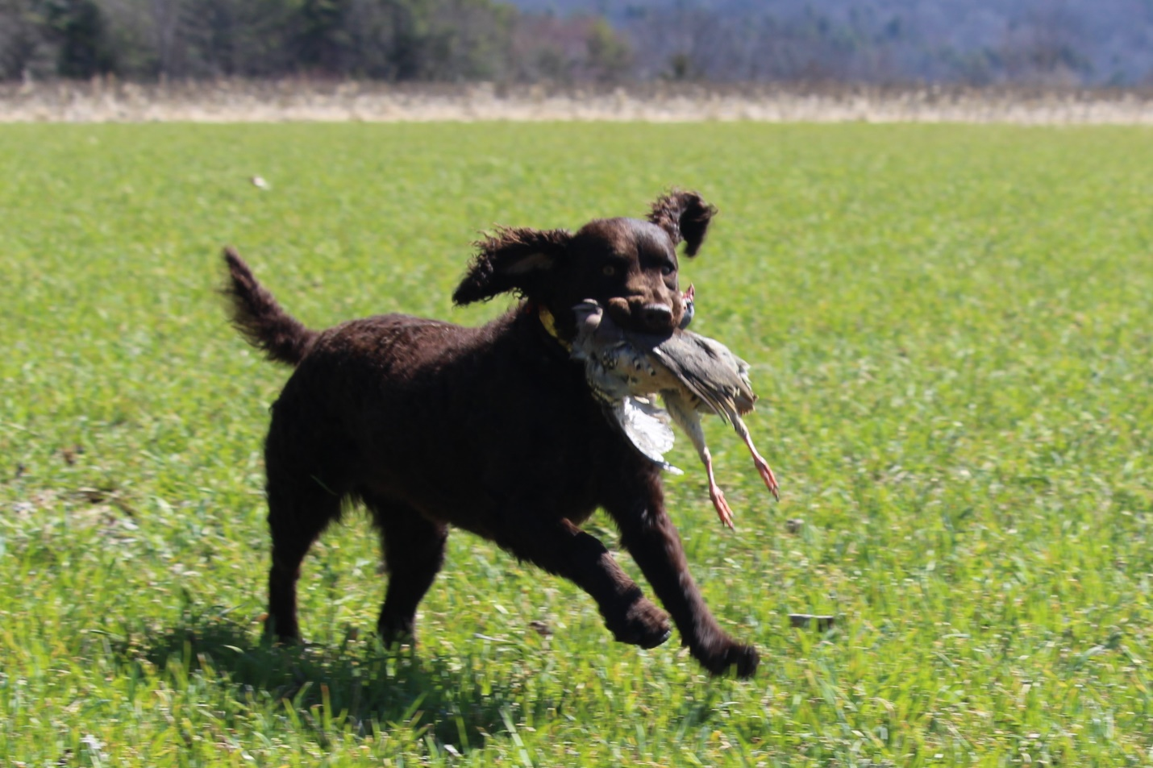
Puppy and Natural Instinct Abilities Test Sign-up Form

Owner’s Name:_________________________________
Handler’s Name (if not owner):____________________
Dog’s Registered Name:__________________________
______________________________________________
Dog’s Call Name:________________________________
Age:__________________________________________

Will you be bringing your own bumper or toy to use in the test or would you like to try a dead bird?________________

Is there anything else it would be helpful for the judges to know:___________________________________________________________________________________________________
Please send completed form to:

Christine Dostie, 981 Church Hill Rd., Leeds, ME 04263

